Test 9277
Problems 61-70

61
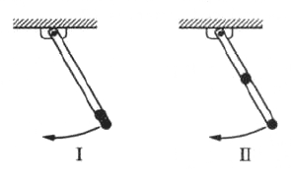

A long, straight, and massless rod pivots about one end in a vertical plane. In configuration I, shown above, two small identical masses are attached to the free end; in configuration II, one mass is moved to the center of the rod. What is the ratio of the frequency of small oscillations of configuration II to that of comfiguration I?
- 6/5
- 3/2
- 5/3

62

A mole of ideal gas initially at temperature and volume undergoes a reversible isothermal expansion to volume . If the ratio of specific heats is and if R is the gas constant, the work done by the gas is

- zero

63
Which of the following is true if the arrangement of an isolated thermodynamic system is of maximal probability?

- Spontaneous change to a lower probability occurs
- The entropy is a minimum
- Boltzmann's constant approaches zero.
- No spontaneous change occurs.
- The entropy is zero.

64

If an electric field is given in a certain region by , where k is a nonzero constant, which of the following is true?

- There is a time-varying magnetic field.
- There is charge density in the region.
- The electric field cannot be constant in time.
- The electric field is impossible under any circumstances.
- None of the above.

65

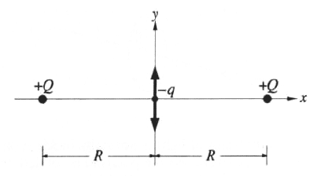
Two point charges with the same charge are fixed along the x-axis and are a distance 2R apart as shown. A small particle with mass m and charge is placed at the midpoint between them. What is the angular frequency of small oscillations of this particle along the y-directions?

- 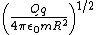
- 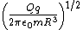
66
A thin uniform steel chain is 10 meters long with a mass density of 2 kg per meter. One end of the chain is attached to a horizontal axle having a radius that is small compared to the length of the chain. If the chain initially hangs vertically, the work required to slowly wind it up on the axle is closest to

- 100 J
- 200 J
- 1,000 J
- 2,000 J
- 10,000 J

67

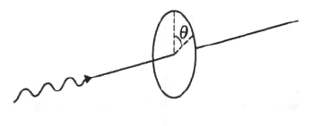
A steady beam of light is normally incident on a piece of polaroid. As the polaroid is rotated around the beam axis, the transmitted intensity varies as , where is the angle of rotation, and A and B are constants with . Which of the following may be correctly concluded about the incident light?

- The light is completely unpolarized
- The light is completely plane polarized
- The light is partly plane polarized and partly unpolarized.
- The light is partly circularly polarized and partly unpolarized.
- The light is completely circularly polarized.

68

The angular separation of the two components of a double star is 8microradians, and the light from the double star has a wavelength of 5500 A. The smallest diameter of a telescope mirror that will resolve the double star is most nearly

- 1mm
- 1cm
- 10cm
- 1m
- 100m

69

A fast charged particle passes perpendicularly through a thin glass sheet of index of refraction 1.5. The particle emits light in the glass. The minimum speed of the particle is

- c/3
- 4c/9
- 5c/9
- 2c/3
- c

70

A monoenergetic beam consists of unstable particles with total energies 100 times their rest energy. If the particles have rest mass m, their momentum is most nearly

- mc
- 10mc
- 70mc
- 100mc
- mc

